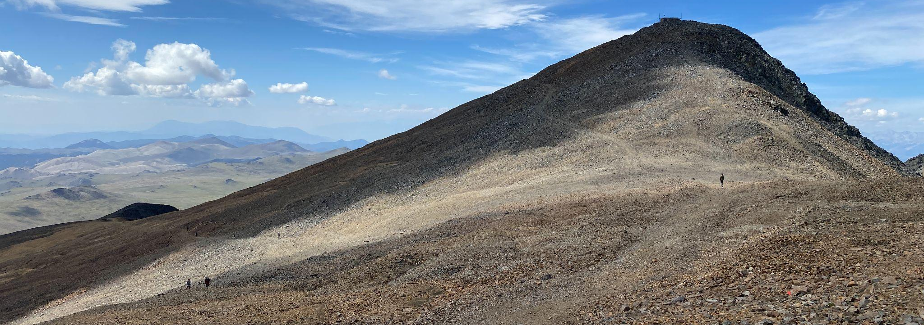

2024 GLORIA White Mountains Field Work Gear List

Conditions in the alpine are often like a very cold desert. As such, expect strong sun, dry conditions, and big swings in temperature between day and night! Gear lists are always difficult because what works for one person doesn’t necessarily work for another, and many choices come down to personal preference. Below is a list of some thoughts for good gear packing. Disclaimer: We can’t promise this is comprehensive for every participant :)

Clothing and Sun protection

Because of the constantly changing conditions, the best way to dress in the alpine environment is in layers. By layers, I mean having clothing that fits over other clothing. For example, I might start out the day in pants, a light wool base layer, a shirt and a fleece. When the afternoon becomes cold and windy as a thunderstorm approaches, I might put on gloves, rain pants, a puffy jacket and a rain jacket. When the storm passes, I might take off the rain layers to stay comfortable. Throughout the day I am doing my best to keep protected from the sun—it is very powerful at 12,000 ft!

- Rain jacket
- Rain pants
- Gloves
- Warm hat / beanie
- Socks (a hiking pair, a super warm sleeping pair)
- Baselayers (bottom and top)
- Field shirts (long sleeve, and sun shirts are great too)
- Field pants
- Fleece
- Puffy jacket
- Sunglasses (a backup pair is not a bad idea)
- Sun hat (the more coverage the better)

Personal comfort and hygiene

- Soap
- Bath towel
- Toothbrush, toothpaste, floss
- Sunscreen
- SPF chapstick (crucial!)
- Medications (if any)
- Small personal first aid kit (we’ve got the big stuff)
- Saline nasal spray
- TUMS / Antiacid tablets
- Mosquito repellant (I like DEET wipes)
- Extra personal snacks, hydration tablets, treats :)

Footwear

We will be spending time moving over loose rock, as well as walking for a few hours at a time. Comfortable yet protective shoes are a must, and those that can lend some peace of mind on loose terrain are all the better.

- Hiking/field work shoes (boots work well for many people)
- Sandals
- Comfy hangout shoes

Sleeping

Since WMRC does NOT provide bedding, and a good night’s sleep is crucial:

- Sleeping Bag (20F or warmer is recommended)
- Your favorite pillow
- Pillowcase
- Something to cover the bed with (sheet/ground-cloth/tarp)
- Earplugs / eye mask

Other Items

- Daypack (25-40 liters)
- Headlamp with extra batteries
- Phone, wallet, keys!
- Binoculars (if you have them)
- Wristwatch
- Laptop
- Charging cords
- Field notebook, pencil, pen
- Fun stuff (paints, musical instruments, hula hoop…)
- Hiking poles (if this is your jam)
- Two 1L refillable water bottles (at least)
- Personal tupperware for packing lunch

