Downslope Surveys, WMRC GLORIA (Global Observational Research in Alpine Environments):
History, Strategy, Field Methods
Jim Bishop, revised July 2016
Michael Koontz, Seema Sheth, Brian Smithers, Jim Bishop, Catie Bishop, Jan Nachlinger, Kaleb Goff; revised April 2023

Overview and brief history
Early in the California GLORIA project, to sample across the entire alpine zone, we decided to survey from the summits downslope into the treeline woodland. This would give us the ability to analyze larger-scale species or plant community shifts in elevation. In addition, such surveys would indicate which plant populations were in position to move upslope and onto the summits sampled by the GLORIA protocol and would also support other studies of plant distribution such as for the upper limit of shrubs.
Initially, it was proposed that we use the 10mX10m plots as used on the GLORIA summits, spaced at 25-meter elevation intervals down the slope below the summit. In 2006 several plots were tried on the slopes below Patriarch Grove South, using various sampling protocols. We chose instead a 1mX100m belt transect along the elevation contour. There would be 100 point samples taken along the transect to match the GLORIA 10mX10m area and sample density already in use on most GLORIA Great Basin summits. The 100 points would not adequately sample the many low-cover plants (often less than 1% areal cover). So, in addition to the point samples, all the species occurring in each 10m segment along the belt transect would be recorded, and that would give a measure of their presence. (Note: One exception is the first Barcroft downslope survey, 2011, in which the species occurrence was noted in two 50-meter segments of each transect.)
Downslope transects were established in 2007 and 2008 on generally SE-trending slopes below White Mountain (WMT), Barcroft (BAR), Sheep Mountain East (SME), and Patriarch Grove South (PGS). The transect ranges overlap vertically and provide a survey covering the entire elevation range from 4300m to 3300m, extending into the Bristlecone-Limber Pine woodland. The figure below outlines one belt-transect segment, with sample points.

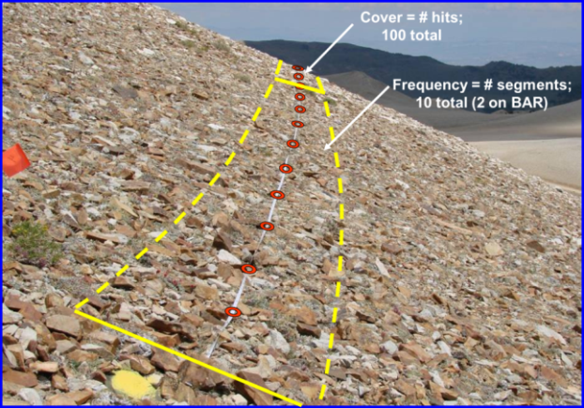

Current downslope project
In 2011, 2016, and 2022, two of the downslope surveys were repeated, BAR and SME. In 2012, 2017, and 2023 WMT and PGS were repeated. In 2013 and 2018, a downslope survey was done on Campito Mountain, CPT.
Since the first downslope surveys were done, the international GLORIA program has adopted the “California Method” of 10mX10m survey plots. The new international protocol for those plots increases the number of sample points from 100 to 400 points (taken on a ½-meter grid). The current downslope surveys increase the belt-transect sample points to 400 to match the GLORIA protocol, and to increase the resolution of plant-species cover and general cover types. The present 10-segment, 400-point belt transect matches the summit 10mX10m plots exactly in area, segmentation, and sample-point grid. The figure on the last page shows the transect layout convention. The downslope protocol has been included as a supplement to the international summit protocols.

Survey protocol, (updated for clarity in July 2022)
From the origin (center) point a tape is extended 50 meters each direction along the elevation contour, defining the centerline of the belt transect. The 1 m belt straddles the tape, 0.5 m on each side. The belt is divided into ten, 10-meter segments.
Four hundred (400) sample points are taken on each transect. The points lie 0.25 m to either side of the tape, at each 0.5 m along the tape. Each 10 m segment will have a total of 40 sample points. That distribution exactly matches the sample-point distribution of the GLORIA summit 10mX10m plots. The figure below left illustrates the placement of sample points in one 10-meter segment. The right figure shows our indicator stick (a.k.a. “bident”).
The sample-point distribution provides 400 points uniformly distributed over the 100 m² area of the belt transect. Each point will be positioned by its place along the tape and distance from the tape, which will preclude observer bias in selection of the sample-point target. Those are the objectives of the point-sampling protocol: uniform distribution of sample points, and unbiased placement of each point.
Each transect segment is photographed, showing the end-point flags and the tape position. Those photographs will allow the tape in future surveys to be placed very close to the same transect line. It also allows correlation of micro-habitat type with plant occurrence.
As a practical matter, the downslope resurveys will not achieve replication of placement better than the order of centimeters. That imprecision does not impair the basic standard of uniformly sampling with 400 unbiased points; they will effectively survey the same plot with the same method.
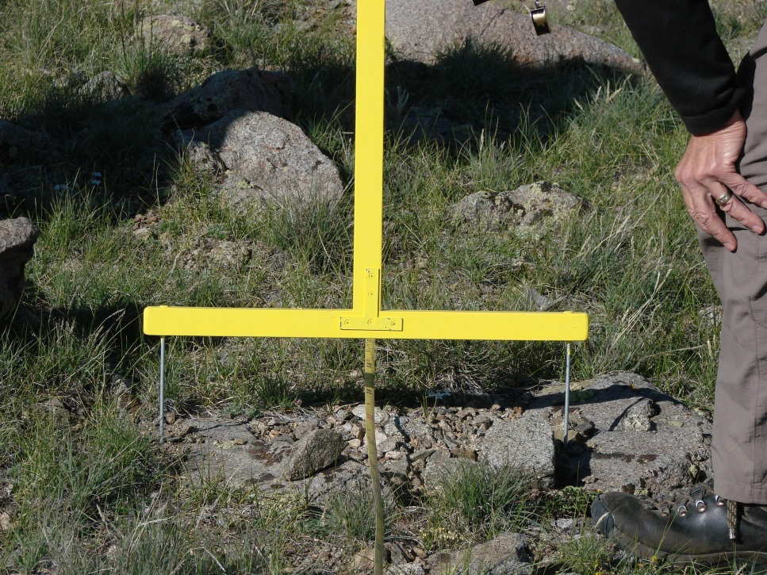
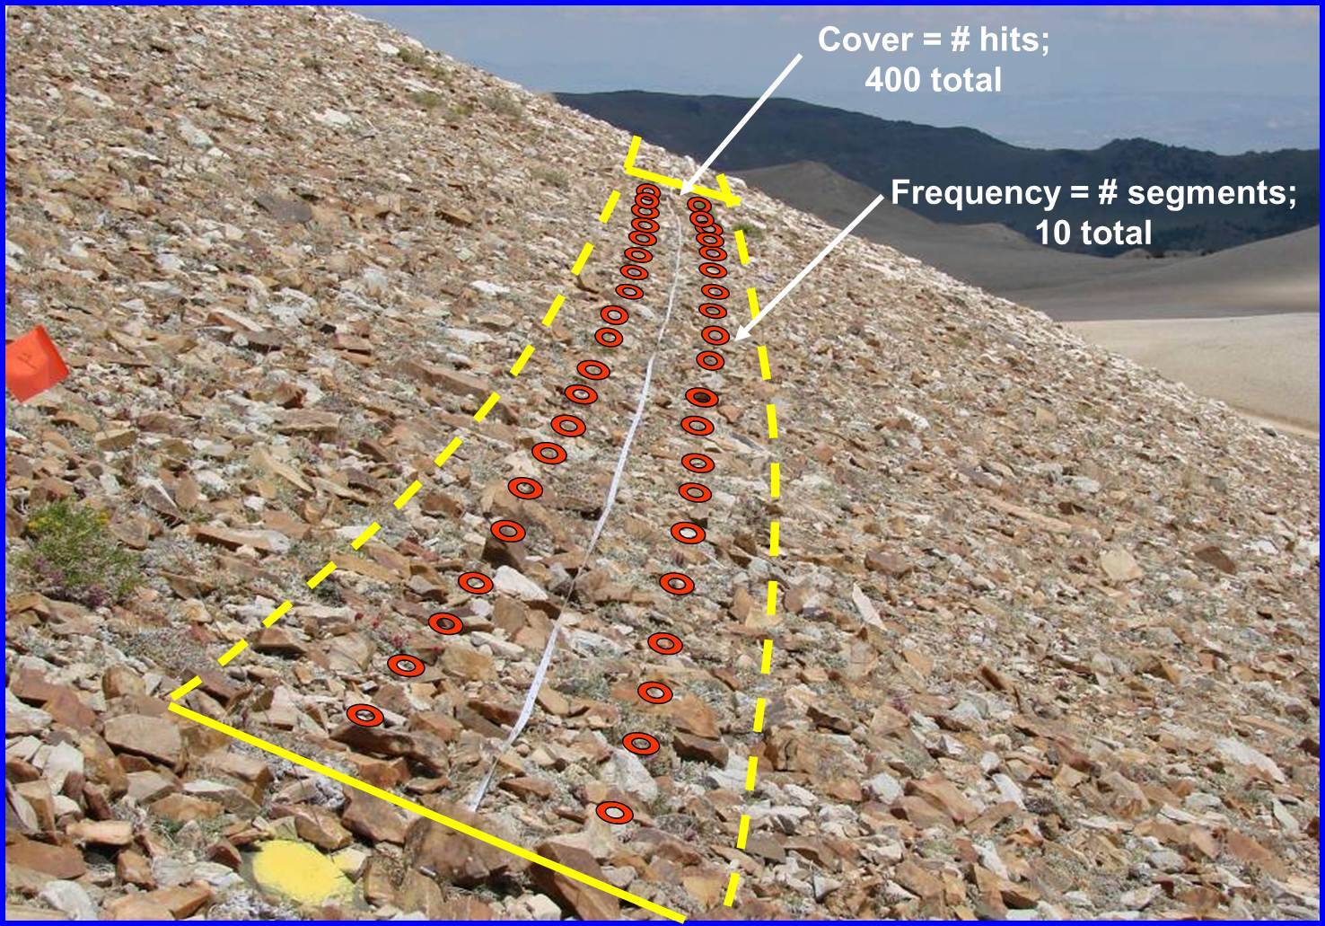

Classifying the presence/absence
If the canopy-outline of a vascular plant falls within the 1m width of the belt transect, count that species as “present” within that transect. That is, presence/absence of a species is *not* based on whether the plant is rooted inside or outside of the belt transect. For example, if a branch of a tree hangs over the transect segment (regardless of how high off the ground that branch might be), then the species of tree would be counted as “present” for that segment. For graminoids it is not always so obvious what is the canopy outline. The guideline used in our early GLORIA surveys was to imagine a soft net dropped over the plant—it will drape from the highest and outermost parts of the plant and will sag gently inward in between those parts. If the outline of the imaginary net falls within the belt transect, the plant is present in that segment. The idea is to represent the ecological “presence” of the plant—and that presence involves the crown, the roots, and the influence of the plant in limiting the space of nearby plants. Assuming consistency, we’ll have a basis for observing change over time.
We also want to capture situations with “overstory” vegetation that could influence the microsite conditions nearer to the ground (e.g., light/shading throughout the day/year, moisture regimes, snow retention, wind conditions). If any canopy outline of a vascular plant falls within the 1m width of the belt transect and that canopy outline is above a height of 1.35m (~chest height), that species is also recorded as being present in “overstory” form. For example, if a bristlecone pine branch extends over the transect at a height of 1.35m, then bristlecone pine is recorded as “present” as though it is another species: “Pinus longaeva (overstory)”. The determination of whether the species is overstory or not is made based on the branches overlapping the transect, not based on the height of the tree itself. That is, if the tree is 4m tall, but the branch overlapping the transect is lower than 1.35m, then the species is not considered overstory.

Classifying the point sample
Use the same “imaginary net” approach for classifying the point sample as used for the presence/absence. If the point falls within the canopy outline (i.e., within the outline of the imaginary net) of a vascular plant, count it as a hit on that species. If dead material is still attached to the plant, the hit is on the plant. Detached dead material is “litter”.
Rock or scree? That question generates discussion every year. At one time, “rock” meant only “bedrock”. But that is often an impossible judgment to make just by looking (even for a geologist). More recently we concluded that the distinction was meaningful only if it reflected the ecological influence of the rock/scree. A small rock can be displaced by a growing plant, and there are adjacent spaces amongst scree into which a plant can come up. A rock so large, whether it is bedrock or just a large boulder, that it is immovable and offers no substrate for a plant has a different ecological influence. In effect those areas are unavailable to contribute to plant cover, and their measure sets a limit on the potential cover by plants. We view “rocks” as those that offer no potential for plant establishment over the area that they cover—in effect area removed from potential plant habitat. If the rock would essentially prevent colonization by plants, and would not be significantly overgrown by a plant canopy in that setting, think of it as “rock”. Scree is smaller rocks, those among which plants could become established and grow. The ‘kick test’ is a good proxy for this: if the substrate is kicked and it moves, we call it “scree”. If it does not move, we call it “rock”. The other convention is that small rocks “smaller than a garbanzo bean” are considered to be “bare ground”.
To capture “overstory” vegetation in the pointing hits measurement type, we determine whether the canopy outline of the vascular plant intersects with the pointing hit above 1.35m of height. If it does, then the pointing hit is recorded as though it is a separate species. For example, if a pointing hit intersects with a bristlecone pine branch at 1.35m of height, then a hit is recorded for “Pinus longaeva (overstory)”. As with other pointing hits, it is possible for multiple hits to be recorded for the same point if there are multiple overlapping vascular plants. For example, if the bristlecone pine branch at 1.35m hangs over a Hymenoxys cooperi below 1.35m, then one hit would be recorded for “Pinus longaeva (overstory)” and one hit would be recorded for “Hymenoxys cooperi”. It is also possible that the same species would get a “hit” at a single point if it exists both above *and* below 1.35m. For example, a bristlecone pine branch intersects the point at 1.35m and a lower branch intersects the point at 0.75m would be recorded as a hit for both “Pinus longaeva (overstory)” *and* “Pinus longaeva”. If there are *no other vascular plants* underneath an overstory hit, then we also record the substrate at the point. For example, if a bristlecone pine branch intersects the point at 1.35m, there aren’t any other vascular plants between that branch and the ground, and there is “rock” at the ground, it would be recorded as a hit for “Pinus longaeva (overstory)” *and* a hit for “rock”. Note that this may result in more “hits” than actual point locations for measuring those hits.

Field process
We assume a 3-person field team (or more) in the following suggested regimen. All of it can be done with fewer, or with more, people, and experience will allow fine-tuning that improves the team’s efficiency.
1. For the initial survey, extend the 50-meter tape to the left (looking uphill) from the transect origin along the contour (see diagram last page). A GPS or clinometer can help with maintaining a consistent elevation. For a flat land surface, that line has a constant direction, but for a realistic curved land surface that is a curved line. The tendency is for a person to keep walking more-or-less perpendicular to the fall-line they started from, and to slip down (usually) or up as the land curves. It may be helpful for a second person to watch the tape person with a clinometer, or against the horizon, and indicate to go up or down to stay on contour. Walking back along the tape mark the 10-meter points with pin flags, and paint spot at the transect ends (or a person coming behind can do that). For resurveys, use the photos taken from previous surveys to lay out the tape as consistently as possible with the previous survey.
2. Meanwhile, the other team members can begin identifying plants in the transect. When the tape is laid walk out the transect, listing every plant in each 10-meter segment. With 3 or more folks a person can walk on either side of the tape calling the new species they see, and a third person can record the species. Make a check mark in the small box at the left end of the cell for that segment. The recorder, or a 4th person, can make sure the plant lookers do not go beyond the end of the segment before starting the species search over again for the new segment. This presence/absence transect can either be done segment-by-segment (10m) or in its entirety.
3. At the end of the transect or segment, return to each segment and record the point samples. Place the T-marker astride the tape at ½-meter intervals, with the long handle directly over the tape, and read the two points indicated on either side. There will be 40 samples per segment (but note that you may occasionally have more than 40 “hits” per segment in the case of overlapping plants at the same point). The recorder can keep track of which segment is being read. If there are enough participants, one person can place the T-marker while a plant person on either side of the transect calls the point. Note: You can begin at the beginning of each segment, and your last pair of points will be ½ meter before the end of that segment.
4. Photos are taken of the origin, each end point, and each segment looking along the transect in the direction from the left end toward the right end. Pick up the tape and the pin flags. Repeat the process for the right half of the transect. It helps to use two tapes and have the right half laid out already or if you have enough participants, they two halves can be completed concurrently.

Recorder duties
1. Complete the information at the top of the form, including start/stop times.
2. Notice the segment where you are beginning and make sure you are marking in the appropriate column. For example, as you work out from the origin on the left half, you’ll be marking segments 5, 4, 3, 2, 1, from the center of the form leftward. And as you work out from the origin on the right half you’ll be marking segments 6, 7, 8, 9, 10 from the center rightward. Working inward from the far end of a transect will be the opposite order of segments.
3. Record each species occurring in a given segment with a mark at the left end of the space for that segment. Don’t make a big mark that extends into the rest of the box…you’ll need that space for point counts.
4. In recording point counts, use a small square of 4 dots to record 1, 2, 3, 4; then 4 lines connecting them in a square to record 5,6,7,8; and finally 2 diagonal lines to record 9, 10.
7. If the number of species exceeds 36 you can use the “Comments” section for another 2 species, by extending the column lines down. If need be, you can attach a second form.
8. Use “Comments” to record such things as a placeholder name given a plant species that is not identifiable in the field, or how an interpretation of what to call something in the point counts was made.
9. Tally the “hits” in the upper “Cover type” (i.e., substrate) section as well as the hits from the lower, vascular plants section in the “Total hits for Column” cell. Reconcile the total numbers before you leave the segment (for example, if you end up with 38 total hits in a segment, you skipped a point location and ought to start the segment again). Note that the total hits for the column (i.e., for each segment) will *always* be at least 40. It is possible to have greater than 40 hits if there were overlapping plants because more than one hit can be recorded for a single point location (this does happen occasionally).

Note: There will be duplicate forms for each transect (with plant lists) and some blank forms. That will allow some flexibility for dual recorders or double-teaming both transect halves if team size allows it. Separate left/right forms will be compiled later onto one form. Species common across the downslope transects may be pre-filled on the data sheet by the Field Coordinator; and recorders should not use this information to prompt botanists about what to plants to look for.

Downslope survey Country ______ Target Region _____ Series Name ______ Aspect ____

Transect #____ Lat________________________ Long________________________+ Elev _______

Date ________Time: from ______ to _______ Observers _________________________________________

Left Transect segment (as you face into the hillside) Right
Cover type | 1 | 2 | 3 | 4 | 5 | 6 | 7 | 8 | 9 | 10 | HitSeg
Bare ground |  |  |  |  |  |  |  |  |  |  | /
Litter |  |  |  |  | Total = 40 hits with substrate and plants (usually)  Safe to ignore this row for now |  |  |  |  |  | /
Rock |  |  |  |  |  |  |  |  |  |  | /
Scree |  |  |  |  |  |  |  |  |  |  | /
Vascular plant |  |  |  |  |  |  |  |  |  |  | /
 |  |  |  |  |  |  |  |  |  |  | /
Total Hits for Column |  |  |  |  |  |  | Total = 400 hits (usually)
Plant species Hit Seg
 | | | | | | | | | | | | | | | | | | | | | /
 | |  Record presence of this species in this segment with a checkmark here | | | | | | | | | |  Safe to ignore this section for now | | | | | | | | | /
 | | | | | | | | | | | | | | | | | | | | | /
 | | | | | | | | | | | | | | | | | | | | | /
 | | | | | | | | | | | | | | | | | | | | | /
 | | | | | | | | | | | | | |  Safe to ignore this section for now | | | | | | | /
 | | | | | | | | | | | | | | | | | | | | | /
 | | | |  Record hits on point samples for this species in this segment in this box | | | | | | | | | | | | | | | | | /
 | | | | | | | | | | | | | | | | | | | | | /
 | | | | | | | | | | | | | | | | | | | | | /
 | | | | | | | | | | | | | | | | | | | | | /
 | | | | | | | | | | | | | | | | | | | | | /
 | | | | | | | | | | | | | | | | | | | | | /
 | | | | | | | | | | | | | | | | | | | | | /
 | | | | | | | | | | | | | |  Origin or center of transect on this form | | | | | | | /
 | | | | | | | | | | | | | | | | | | | | | /
 | | | | | | | | | | | | | | | | | | | | | /
 | | | | | | | | | | | | | | | | | | | | | /
 | | | | | | | | | | | | | | | | | | | | | /
 | | | | | | | | | | | | | | | | | | | | | /
 | | | | | | | | | | | | | | | | | | | | | /
 | | | | | | | | | | | | | | | | | | | | | /
 | | | | | | | | | | | | | | | | | | | | | /
 | | | | | | | | | | | | | | | | | | | | | /
 | | | | | | | | | | | | | | | | | | | | | /
 | | | | | | | | | | | | | | | | | | | | | /
 | | | | | | | | | | | | | | | | | | | | | /
 | | | | | | | | | | | | | | | | | | | | | /
 | | | | | | | | | | | | | | | | | | | | | /
 | | | | | | | | | | | | | | | | | | | | | /
 | | | | | | | | | | | | | | | | | | | | | /
 | | | | | | | | | | | | | | | | | | | | | /
 | | | | | | | | | | | | | | | | | | | | | /
Comments:__________________________________________________________________________________________________
___________________________________________________________________________________________________________
“Hits” (aka “cover”) is the # of points scored for that item: “Seg” (aka “frequency”) refers to the # of segments it occurs in.

